**Database Tables**

**Table 1: Employee**

Emp_Id, E_Name, E_Address, Position, E_Phone, Email

**Table 2: Donor**

Donor_Id, D_Name, D_Address, D_Gender, D_Age, D_Phone

**Table 3: Donation**

Donor_Id, D_date, Blood_type, Units

**Table 4: Hospital**

H_Name, H_Address, H_Phone

**Table 5: Blood Bank**

B No., B_Name

**Table 6: Blood Orders**

B No., Requested by, Date, Issued(Y/N), Issued On, Requested Units

**Table 7: Stock**

B No., Blood type, Units

**Table 8: Blood Code**

Blood Code, Blood Type, cost

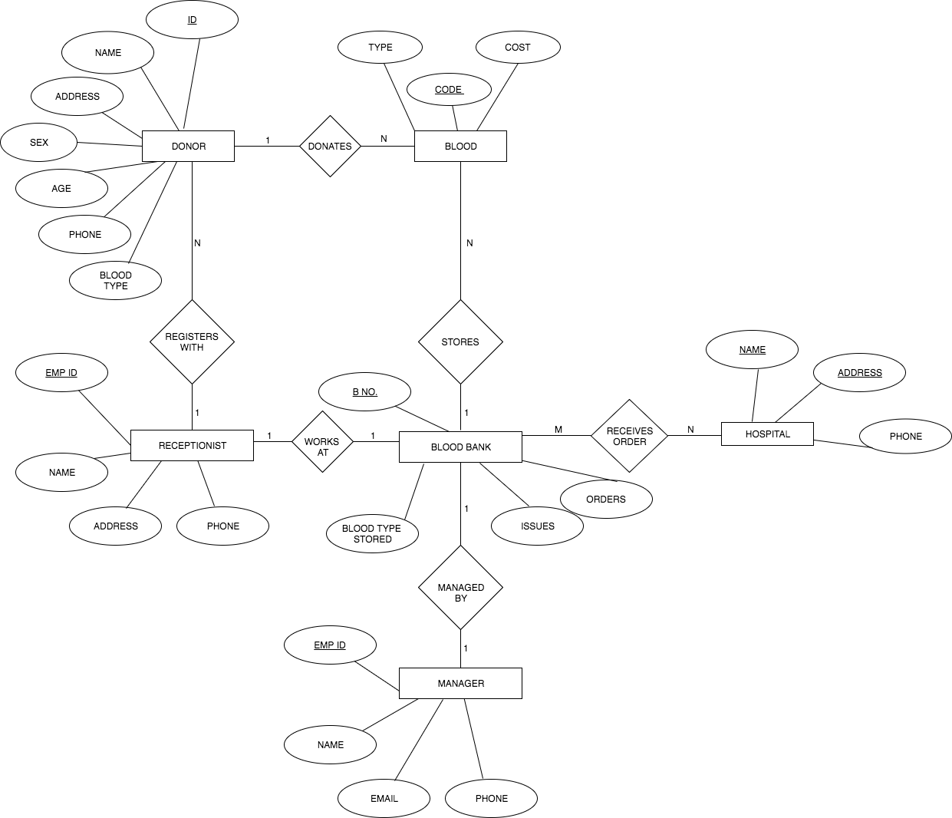

**ER DIAGRAM**